## MODULE 2: CLOUD ADOPTION JOURNEY: IDEATION PRACTICES

#### Topic 1: Cloud Transformation with the IBM Garage Method

**Introduction**

In this topic, we'll explore the current frameworks and practices that organizations need to consider as they embrace digital reinvention.

Throughout this topic, we will attempt to answer the following questions:

**1 . What are some of the key factors and strategies that an organization should consider when moving toward modernization and digital transformation?**

The IBM Garage Method for Cloud is a method that combines practices from Design Thinking, Lean Startup, Extreme Programming, and DevOps to allow teams to quickly realize business outcomes.

**The New Digital Age**

For traditional organizations, Digital Reinvention involves a fundamental ground-up reinvention of strategy, operations, and technology; and, while technology can be a great contributor and innovator on the cloud adoption journey, a successful transformation needs to focus on more than just technology.

Image of people brainstorming on the new ideas for reinvention of the business

Your people, culture, and processes all play critical roles in achieving the greatest impact for your enterprise. Digital Reinvention requires a change in thinking and culture:

* Strategically, digitally reinvented businesses maintain an overarching focus on experience rather than production.
* Embrace technological change and disruption and conceive their organization within the context of an overall business ecosystem.
* Operationally, digitally reinvented businesses commit to continuous calibration and improvement.
* They foster cultures of everyday innovation among individuals and across the ecosystem, and they work to seamlessly interchange between the physical and digital.

**Transform and innovate with speed**

Culture is key to the success of an agile transformation. Your culture must support small, co-located teams (teams sharing the same workspace) that are autonomous and that can make decisions that are based on efficiency and knowledge. Your squads have a diverse set of skills that support your transformation and enable the team to pivot in response to market feedback.

**Why change?**

One key to culture change is adopting the startup mindset. To move fast, startups eliminate the barriers between innovative ideas and production. They aren’t afraid of redefining everything from development practices to operations, from testing to production, and from tools to management. A radical transformation requires a culture that is focused on innovation.

Cultural evolution enables key business advantages. When you shift to small, empowered teams with the right organizational roles—including product owner, design, and DevOps—team members can gain a deep understanding of the customers who use their products. Each team can deliver new and improved features that the customer wants and change course based on feedback. Pivoting with speed isn't possible when you deliver quarterly or annually.

**What changes?**

Change is challenging. Overhauling the culture of a team and then expanding that culture shift to an enterprise starts with team organization.

**Understand the fail fast philosophy**

Teams must recognize that obstacles are often in the way of getting the right idea. The key is failing fast. Experiment with an idea to see whether it's what the customer wants. Implement only what is necessary to prove the idea, get customer feedback, and learn whether the idea is successful. Even if the idea fails, the team learns from the experience.

Adopting the failing fast mentality doesn't mean a lack of fun. People who work in a fun environment enjoy their work more and produce better results. A little laughter goes a long way!

**Adopt the Agile methodology**

Transformation to continuous delivery starts with understanding agile principles:

* Develop frequently, in short intervals, that incorporate feedback and reflective practices
* Satisfying the customer through early and continuous delivery
* Delivering new function on a short timescale that the team agrees to
* Fostering communications across the team through daily standup meetings and playbacks
* Developing at a sustainable pace
* Reflecting, at regular intervals, on how the team can improve

Depending on how your team wants to organize and work, you can combine agile principles with aspects of Lean development. For example, your team might deliver time-boxed iterations, as prescribed by an agile approach, or it might work in a Kanban approach. The important thing is that the team decides what works best.

**Transform with Cloud Technologies**

Digital transformation can be empowering at an organizational scale. It can help transform the customer experience, power innovation, increase agility and flexibility, reduce operating costs and drive data-based decision-making.

But outdated IT infrastructures and applications too often can stand in the way. Genuine digital transformation — in which enterprises take full advantage of digital technologies such as artificial intelligence, automation, connected devices, and remote collaboration and communications platforms — benefit from a cloud modernization strategy that involves people, processes, and technology.

While each journey is different, there are consistent patterns across large to midsize enterprises:

* Cloud is strategic to virtually every digital transformation journey because it provides rapid access to new technologies from a limitless range of sources, helping speed innovation and time to market.
* Data of all kinds—weather, social, Internet of Things (IoT), patient, partner—is at the heart of every transformation. It fuels the insights needed to help automate business processes, make informed decisions and personalize client experiences.
* The blend of hybrid cloud—public and private clouds used together, and multicloud—the adoption of multiple public clouds—is making hybrid multicloud environments the new normal. This first chapter in digital transformation can be characterized as borderless and heterogeneous, embracing technologies and data, on-premises and off, from many providers.

**2 . Explain the IBM Garage as a methodology for implementing transformation and cloud adoption.**

IBM Garage is a collection of practices woven together as a methodology to bring all of IBM together in helping a client realize business value at the fastest and most efficient rate possible.

**What is the IBM Garage Method?**

The IBM Garage Methodology guides how you work by bringing together an open set of practices with a human-centric, outcome-first approach. By applying design thinking, agile development and DevOps tools and techniques, you'll learn new skills and master new ways of working.

It's important to bear in mind that there is no one right way for an organization to start on the path to digitally transform its business model. A hundred organizations detailing their digital transformation strategies will likely result in 100 different roadmaps. Still, most successful digital transformations are aligned to a company's business strategy and follow two principles:

* They work backward, starting with the ideal customer experience.
* They take a holistic approach to transforming operations.

Enterprises start by envisioning the experience they want customers to have with their product and their brand for as many months or years as they want them to be customers. This objective means they must analyze their market, along with technology trends, to forecast or anticipate how customer needs or expectations may change and to spot opportunities for disruption.

Organizations then determine how they must transform the digital business from end to end, including infrastructure, product development, operations, and workflows. The strength of the Garage Method is its flexibility. Some organizations may find that they wish to undergo a total transformation outlined in the lifecycle; whereas, others may only choose to focus on just a few of the most critical areas. And finally, they bring the customer experience to life and improve it continually in response to opportunity and change.

**How it Works - IBM Garage Method Lifecycle Phases**

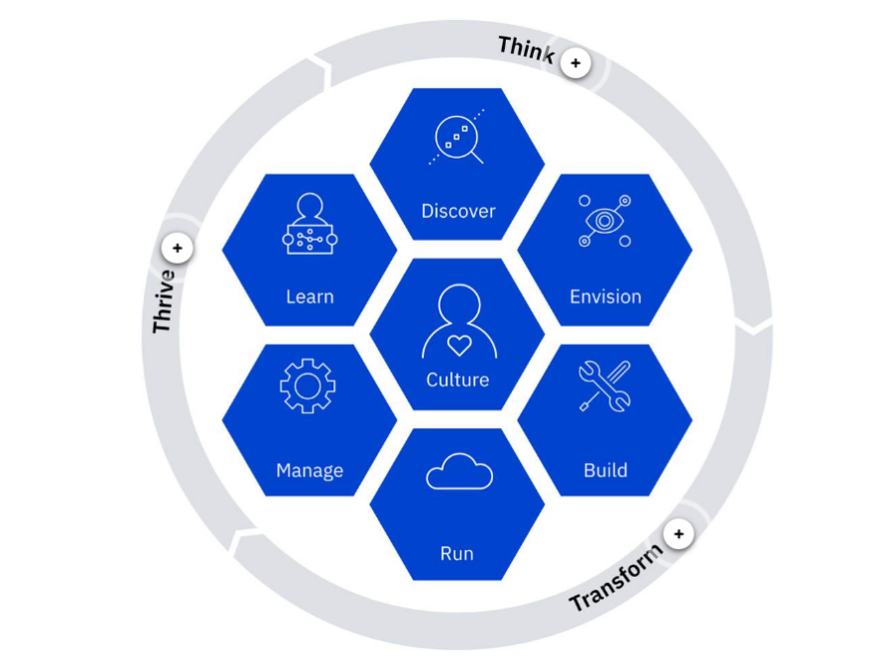

For each of our lifecycle phases—Think, Transform, Thrive—we use a variety of practices from Enterprise Design Thinking, Lean Startup, Agile, DevOps, Site Reliability Engineering, and organizational change (we will be diving deeper into each of these concepts later). Related practices are logically grouped into collections of practices represented by the hexagons (see Figure 1). We have a prescriptive approach for integrating practices across the entire lifecycle. As we mentioned earlier, the digital transformation process isn't just about buying the latest technology or hiring a cloud provider. It involves a re-evaluation of organizational practices and taking a look at company culture to ensure that these practices can thrive. In general, the IBM Garage Method can be broken down into three broad phases: Think, Transform, and Thrive.

By incorporating the IBM Garage Method into their cloud adoption strategy business create an actionable roadmap across a holistic model with measurable targets to ensure their business will thrive while on their cloud journey and transformation.

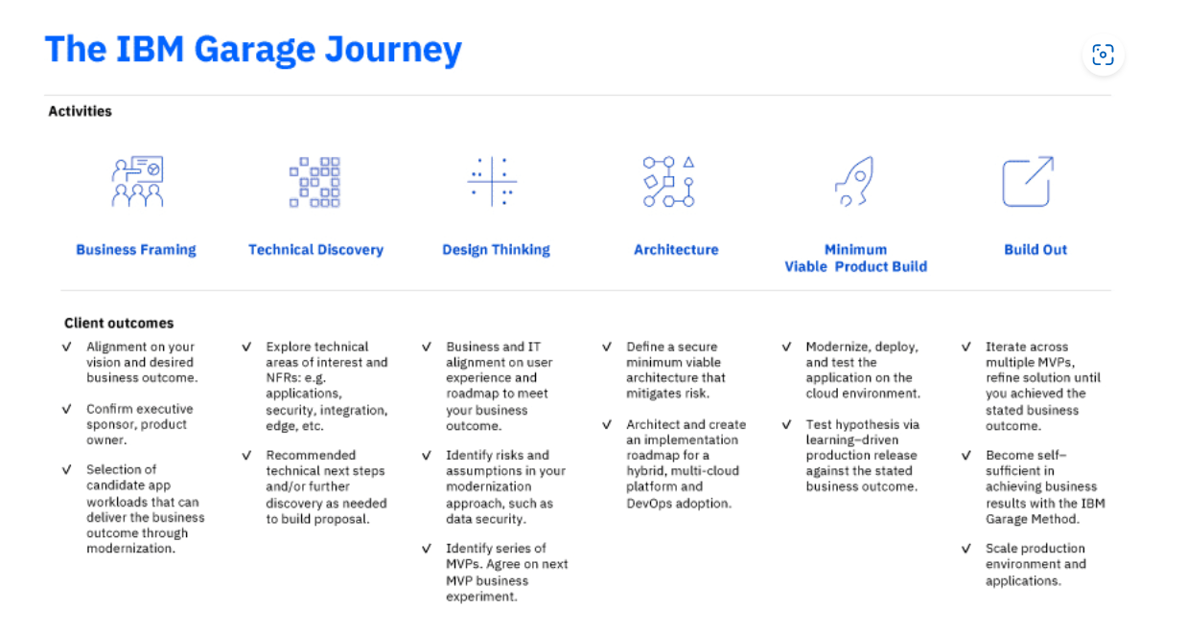

#### Topic 2: Frame Your Business Opportunity

**Introduction**

In this topic, we'll conduct a business framing exercise to better understand our business need and create a minimal viable product.

Throughout this topic, we will attempt to answer the following questions:

**1 . Why should Design Thinking be an essential part of digital transformation and cloud adoption?**

Business Framing- an interactive Enterprise Design Thinking session that helps you explore new potential and prioritize strategic initiatives.

**What is Business Framing?**

During business framing, you gather decision-makers who are familiar with your business's strengths and weaknesses in an activity-based session. The goal is to align on the identification, prioritization, selection, and definition of business opportunities. Business framing clarifies and enlists sponsorship around a selected opportunity’s budget, authority, and timeline.

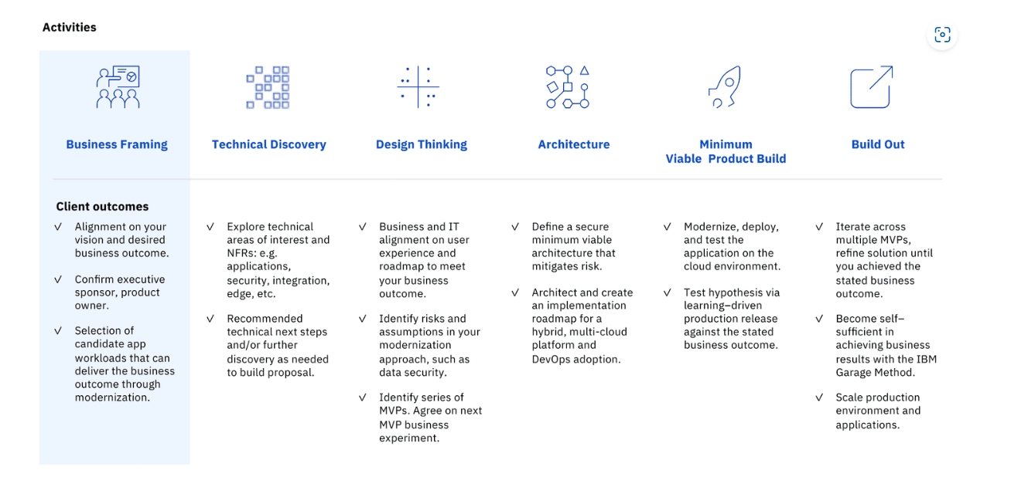

In a business-framing session, opportunities are identified by answering these questions:

* What is your starting point?
* Do you already have a roadmap of opportunities?
* What are key challenges that you have an opportunity to address?
* What is the highest priority opportunity that the team needs to focus on going forward?
* Who is the right person to act as the champion and executive sponsor for your selected project?
* What is the approximate budget and timeline for the project?
* Who has the final authority to approve the project?
* Focus on business opportunities, not technical solutions.

**2 . How does Business Framing fit within the context of user-centric design and creating the best possible MVP?**

**Conduct a Business-Framing Session**

You can conduct business-framing activities during a facilitated session either in person or remotely. Select representatives from business and technical roles to participate in the discussion. The business representative provides the business strategy perspective to the discussion. An architect, a designer, and one or more subject matter experts from relevant technical areas can also provide input in your session.As you conduct your business framing session, use whiteboards or MURAL to capture information throughout the conversation. Storyboarding tools such as MURAL are especially useful if you are conducting your discussion with remote participants.

Business-framing sessions are not meant to be rigid. You can customize them based on your needs. For example, you might include education on a technology or practice area if that is necessary to set greater context before you dive into your opportunity spaces.Conduct your business-framing session by facilitating activities that help you align on a common vision; define, refine, and prioritize your opportunities; and align your team to advance a high-priority opportunity.

**Align on a common vision**

Before you start to identify your opportunities, take time to align on a common vision. Think about where you want your enterprise to be in several years. Determine the internal and external challenges that stand in the way of reaching your goals. Finally, consider all of the resources and advantages that you can use to reach your goal.

**Ideate and cluster opportunities**

Ideation is the process of generating big ideas. Enterprise Design Thinking explains big ideas by contrasting them with features:

* Big idea: Algorithms to predict the future from the past
* Feature: Charts with lines that show prediction

Moving to big ideas takes your mind out of the problem space and into the realm of solutions. This realm is where you innovate and create revolutionary, rather than evolutionary, designs.

In the ideation process, have each member of the team put a minimum of five big ideas on the wall. Of each person's five big ideas, at least one must break the laws of physics. The goal here is to think big without inhibition. This last rule forces each member of the team to step out of their current thought process. It's a nod to the famous quotation attributed to Albert Einstein, "We can’t solve problems by using the same kind of thinking we used when we created them."

Ideate on your challenges. Identify the people who are affected by each challenge and the business outcome that is achieved if the challenge is addressed. During this activity, each person in the session contributes at least five ideas. Each grouping — people, pain, and business outcome — represents an opportunity with a clearly defined business outcome. After the opportunities are created, the facilitator groups them to eliminate duplicates and to identify overlapping opportunities.

**3 . How to put all this into practice through a real-life industry example?**

1 . Frame your business opportunity - the goal of the Business Framing Exercise is to align on the identification, prioritization, selection, and definition of business opportunities.

2 . Align to a common goal - think about where you want your enterprise to be in several years. Determine the internal and external challenges that stand in the way of reaching your goals. Finally, consider all of the resources and advantages that you can use to reach your goal.

3 . Ideate and cluster opportunities - ideation is the process of generating big ideas. Enterprise Design Thinking explains big ideas by contrasting them with features.

#### Topic 3: Embracing User-Centric Design

**Introduction**

In this topic, we'll talk about how to use Enterprise Design Thinking practices to create a minimum viable product.

Throughout this topic, we will attempt to answer the following questions:

**1 . What is the general process for conducting an Enterprise Design Thinking session?**

Design thinking is a human-centered, iterative approach to problem-solving.

Instead of defining a project by its structural components or technological requirements, design thinking focuses on how an idea might help an end-user achieve specific goals.

**What is Enterprise Design Thinking?**

You can't solve a problem without first understanding the problem. In the Think phase of the IBM Garage Method, we conduct discovery practices to help the client team dig deep into the problem domain, align everyone on common goals, and to identify potential problems and bottlenecks. They also help self-assess and understand focused areas of opportunity.

Here we use Enterprise Design Thinking (EDT) to incrementally deliver (being Agile) awesome solutions. Enterprise Design Thinking is a user-focused approach to innovate and establish brand differentiation that focuses on user-centric outcomes.

As we talked about in module 1, the initial focus is on defining a minimum viable product (MVP), which is the bare-minimum experience that achieves user-centric outcomes. As you build each MVP, your teams play back to your stakeholders to determine whether you’re delivering a product that meets the needs of your target users. This agile approach enables seamless pivots to be made in alignment with achieving desired outcomes.

**2 . How can EDT processes be applied to creating business solutions?**

**Important Components of Enterprise Design Thinking**

Enterprise Design Thinking involves several components. But remember this is a general framework for generating ideas, not a pipeline that must be strictly adhered to. Choose the activities that are best for your development team and the end-user.

* Personas
* Empathy maps
* As-is scenarios maps
* Design ideation and prioritization
* To-be scenario maps
* Wireframe sketches
* Hypothesis-driven design
* Create a Minimum viable product (MVP)

**3 . What are the three components for implementing a design?**

Let's say that you think you have a great idea for a new product. Or, maybe you already created a product and your competitors just released an update that ahead of yours. Either way, you need a proven process for innovating and delivering fast. You need Enterprise Design Thinking.

**Implementing Enterprise Design Thinking**

Enterprise Design Thinking starts by bringing together a series of traditional design techniques, such as personas, empathy maps, as-is scenarios, design ideation, to-be scenarios, wireframe sketches, hypothesis-driven design, and minimum viable product (MVP) definition.

To these traditional design approaches, Enterprise Design Thinking adds three core practices: hills, playbacks, and sponsor users.

**Hills**

Enterprise Design Thinking created the notion of hills to provide a new business language for alignment around user-centric market outcomes, not feature requests. This new business language is rooted in user needs and desires. Each hill is expressed as an aspirational end state for users that is motivated by market understanding. Hills define the mission and scope of a release and serve to focus the design and development work on desired, measurable outcomes. For each project, define no more than three major release hill objectives plus a technical foundation objective.

**Playbacks**

As your effort moves forward, you'll want to obtain lots of feedback. You need playbacks. Playbacks align your team, stakeholders, and users around the user value that you plan to deliver, rather than project line items. All design and development work is iterative. To scale in an iterative world, Enterprise Design Thinking formalizes these sessions into iconic playback milestones that align everyone around a set of high-value scenarios that show the value of your offering.

Early playbacks align the team and ensure that it understands how to achieve a hill's specific user objectives. In later playbacks, the development team demonstrates its progress on delivering high-value, end-to-end scenarios.

**Sponsor Users**

Sponsor users, a special component of Enterprise Design Thinking, are people who are selected from your real or intended user group. By working with sponsor users, you can better design experiences for real target users, rather than imagined needs. If at all possible, engage sponsor uses when you create your personas, and continue to include them throughout the entire design and development process.

As you engage sponsor users on a regular basis throughout the release cycle, your relationship deepens, and their feedback provides direct insight into the specialized needs of their business domains. Collaboration between sponsor users and your team ensures that your product is valuable, effortless, and enjoyable.

**4 . How to put all this into practice through a real-life industry example?**

After the team crafts a Business Opportunity Statement, they can turn their opportunity into an implementable solution. They start by conducting an Enterprise Design Thinking workshop. In the workshop, they will define a minimum viable product (MVP) to fulfill the needs that were defined in the Business Opportunity Statement.

The team meets Aisha, our Design Thinking Expert who will introduce them to the process of Enterprise Design Thinking. Aisha explains that at the very heart of Design Thinking is the customer.

* Who are they?
* What problem (or problems) are they facing in their community, business, or life?
* How do they react to these problems?

Empathy maps are "quick and dirty" personas. Generally, empathy maps are low–fidelity works in progress that capture and articulate the facets of a representative user as currently understood and viewed by a team. The facets are thinks, feels, says, and does. For example, this empathy map for our persona Rafa, was developed during a design thinking session:

We found that getting to the root of their problem, and the emotion connected with it, provides a starting point, as well as becomes the driver of our innovation. So, how do you get Deep Customer Empathy? By observing and interviewing your customers to find out what they really want.

Follow Aisha as she walks the team through the three Enterprise Design Thinking actvities:

* Persona - Make it personal by creating a persona for their end-user. Give them a face, a name, and personality to build empathy.
* Empathy Mapping - Put yourself in the shoes of your end-user by imagining what they "think", "feel", "say", and "do" while booking a flight on Acme's current mobile app.
* To-be Scenario - Brainstorm what features your end-user would want to see in the final version of our cloud-based mobile app.v

**Playback Session**

The team then takes these insights back to the stakeholders for the next playback session. The team recommends that a cloud-based mobile app be developed as a first step to moving toward cloud adoption. In this new Agile culture, the development team will deploy a prototype with limited capabilities in order to test how it behaves on the cloud as well as garner feedback gathered during a public beta test of the product.